5.Create a simple cloud software application for Mark Sheet Processing System using any Cloud Service Provider to demonstrate SaaS include the necessary fields such as name of the student, Reg no of the student, Subjects , Marks, Average, percentage, rank, overall performance etc

Step 1:Create the Student details

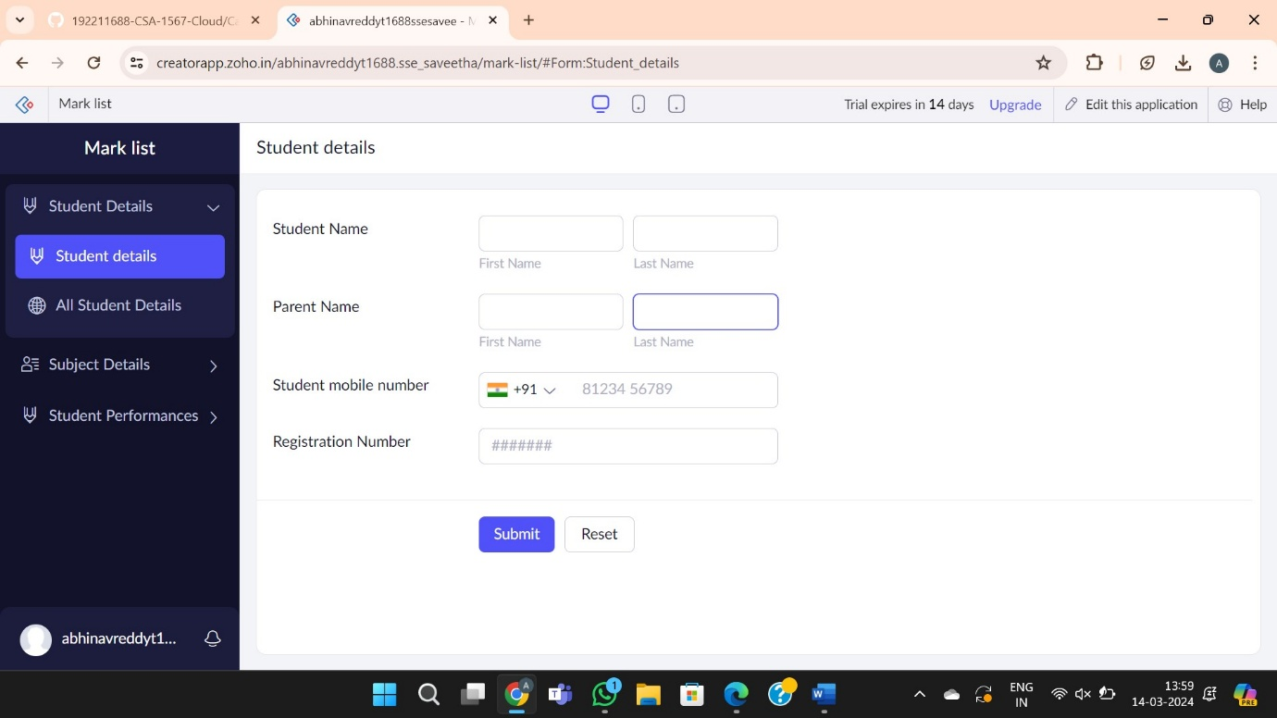

Step 2: create the subject details

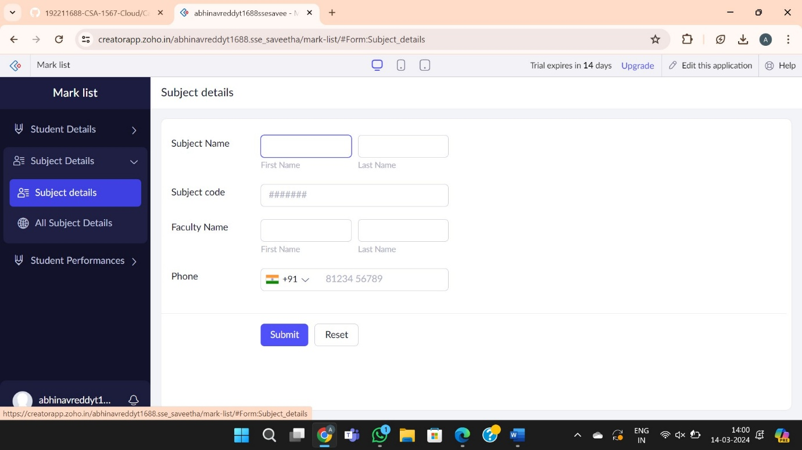

Step 3: overall performance form

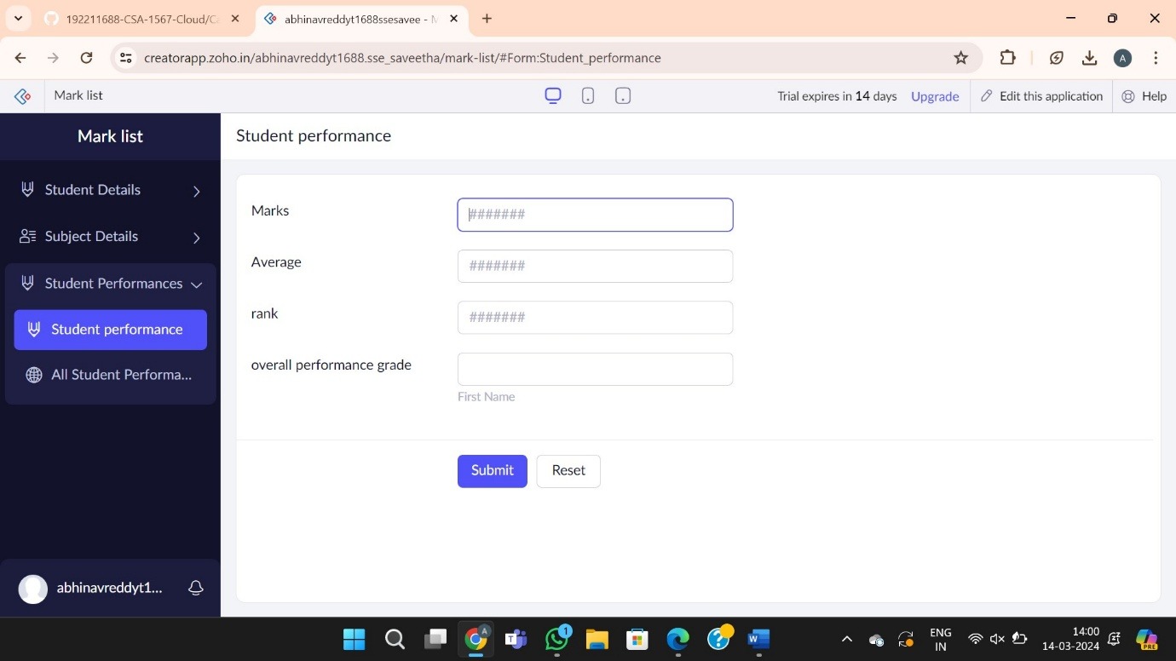

Step4: report forms

